FCHI – Create Check Lot

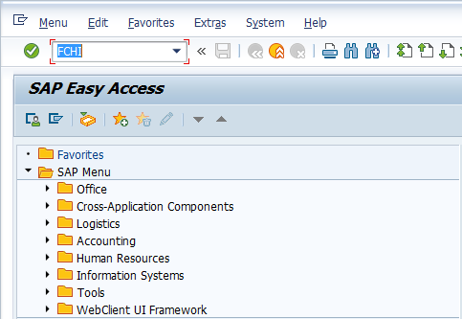

- Input FCHI in Transaction Box and press Enter key

Check Lots Screen.

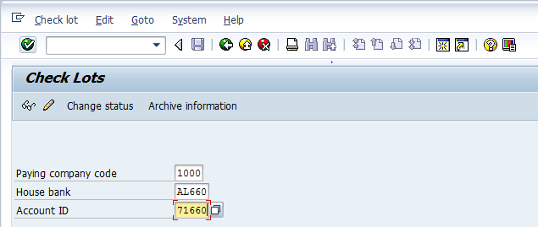

- Paying company code: Input or select payning company code with the help of F4 key
- House Bank: Select house bank with the help of F4 key
- Account ID: Select account id with the help of F4 key
Press Enter key and click on Change icon.

Maintain Check Lots Screen.

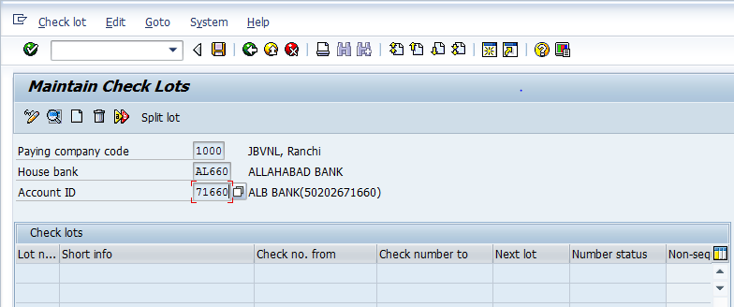

Click on Create icon

Create Lot Screen.

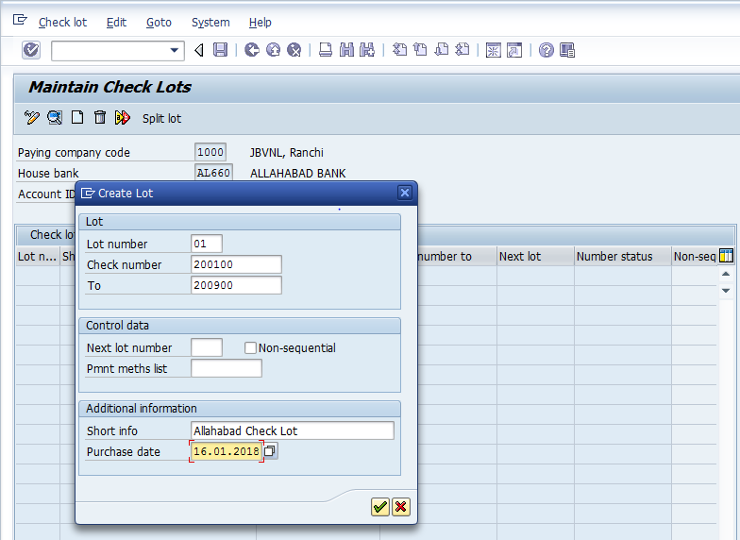

- Lot number: Input required/relevant lot number
- Check number: Input from check number
- To: Input to check number
- Short info: Input short info for the check lot
- Purchas date: Input or select the purchase dat with the help of F4 key
Press Enter key

Maintain Check Lots Screen.

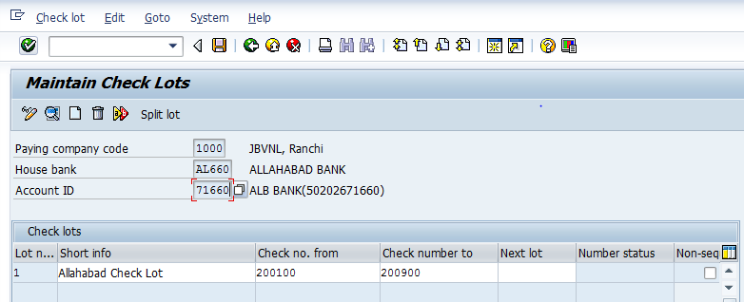

Click on Save icon or press Ctrl+S keys to save the data.

The check numbers have been saved message appears at bottom of the screen

FCH5 – Create Check Information

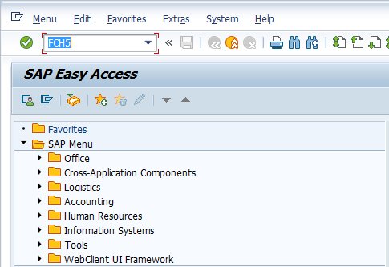

- Input FCH5 in Transaction Box and press Enter key

Create Check Information Screen.

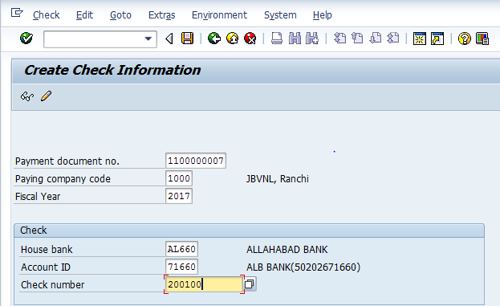

- Payment document no.: Input clearing payment document number
- Fiscal Year: Input fiscal year
- Check number: Input or select the check number with the help of F4 key
Click on Save icon or press Ctrl+S keys to save the data.

The check created manually message appears at bottom of the screen

FCHN – Check Register

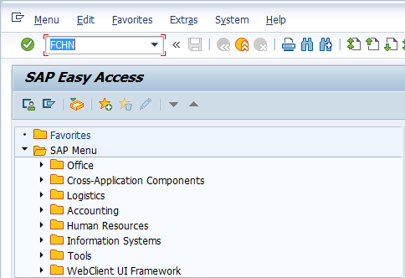

- Input FCHN in Transaction Box and press Enter key

Check Register Screen.

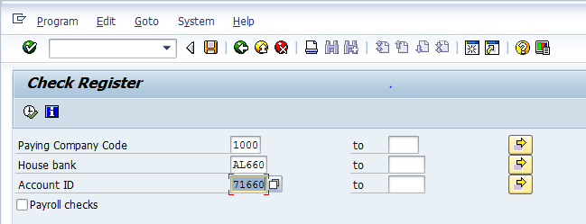

- Paying Company Code: Input paying company code
- House Bank : Select house bank with the help of F4 key
- Account ID: Select account id with the help of F4 key
Click on Execute icon

Check Register Screen.

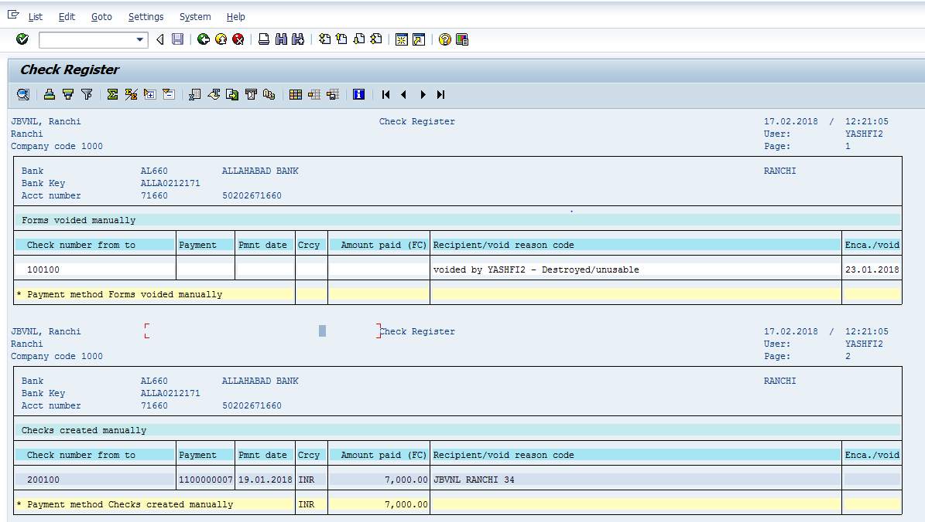

The check 200100 assigned manually is displayed here

FCH3 – Void Checks Not Used

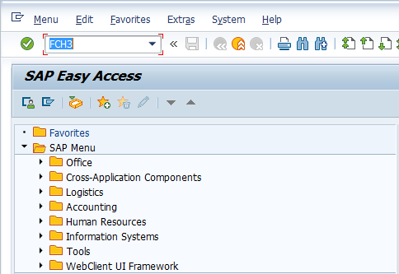

- Input FCH3 in Transaction Box and press Enter key

Void Checks Not Used Screen.

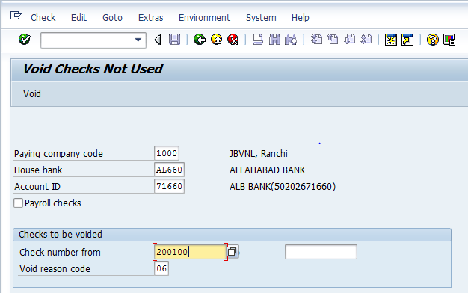

- Paying Company Code: Input paying company code
- House Bank : Select house bank with the help of F4 key
- Account ID: Select account id with the help of F4 key
- Check number from: Input check number from (i.e. starting number of check to be voided)
- To: Input check number to (i.e. end number of check to be voided)
- Void reason code: Select void reason code with the help of F4 Key
Press Enter key and Click on Void button

Checks have been voided message appears at bottom of the screen

FCHN – Display Voided Checks

- Input FCHN in Transaction Box and press Enter key

Check Register Screen.

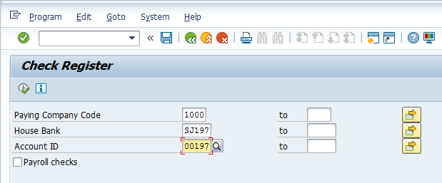

- Paying Company Code: Input paying company code
- House Bank: Select house bank with the help of F4 key
- Account ID: Select account id with the help of F4 key
Click on Execute icon

Check Register Screen.

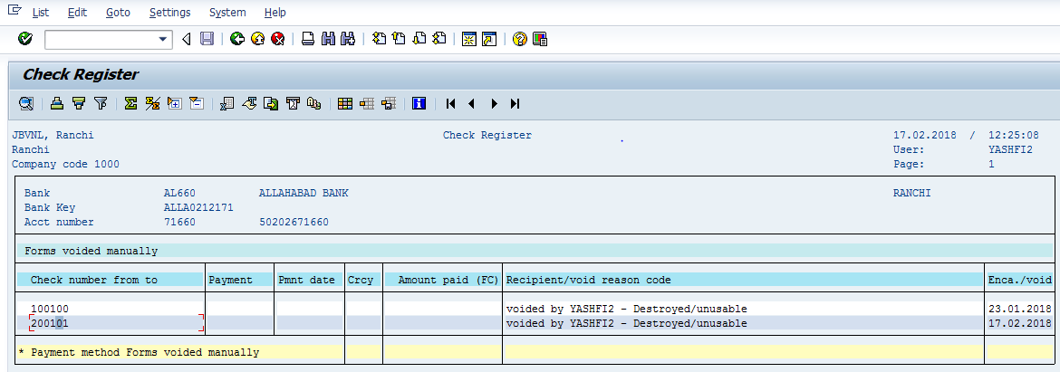

The checks 200101 voided manually are displayed here

FCH8 – Cancel Check Payment

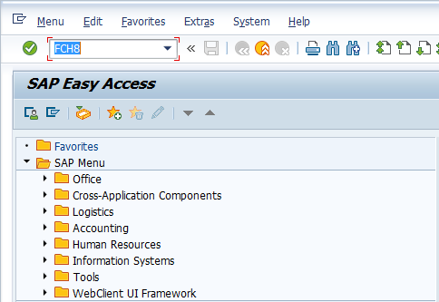

- Input FCH8 in Transaction Box and press Enter key

Cancel Check Payment Screen.

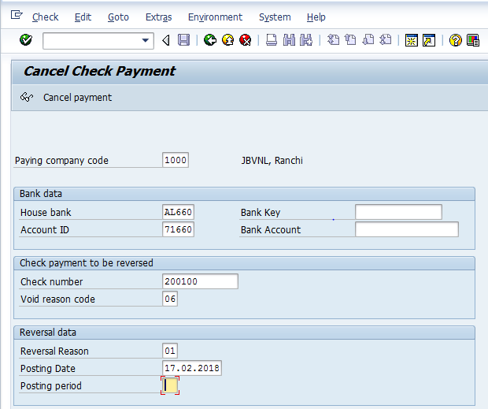

- Check number: Input check number to be reversed
- Void reason code: Select void reason code with the help of F4 key
- Reversal Reason: Select reversal reason with the help of F4 key
- Posting Date: Input or select postin date with the help of F4 key
- Posting Period: Input posting period
Click on Cancel Payment button

Payment for check was cancelled, reverse document message appears at bottom of the screen

FCH9 – Void Issued Checks

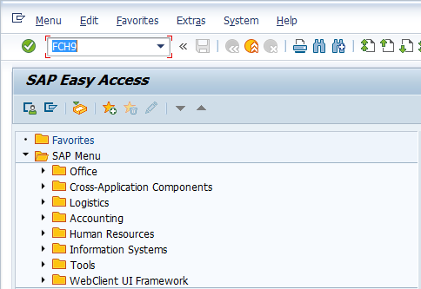

- Input FCH9 in Transaction Box and press Enter key

Void Checks Not Used Screen.

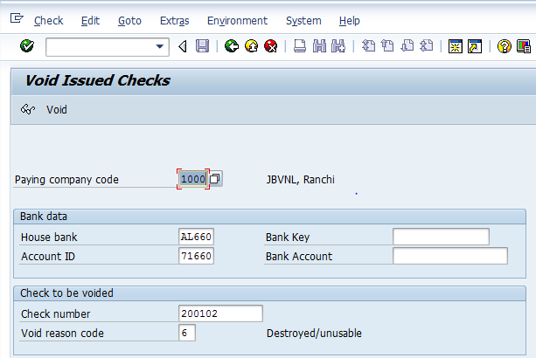

- Paying Company Code: Input paying company code
- House Bank : Select house bank with the help of F4 key
- Account ID: Select account id with the help of F4 key
- Check numbe: Input check number to be voided
- Void reason code: Select the void reason code with the help of F4 Key
Press Enter key and Click on Void button

Check voided, payment document not reversed message appears at bottom of the screen

